**Chronicles of the Digital Age**

**By Eric.w&ChatGPT**

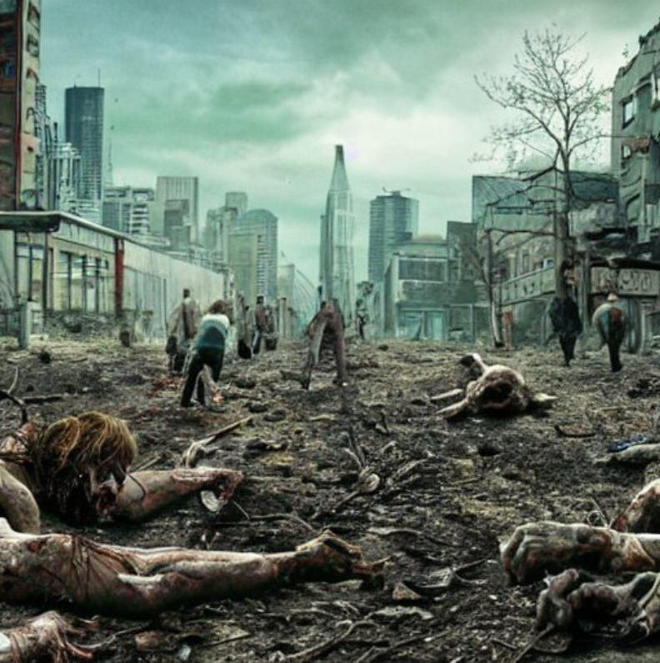

**Contents**

[Chapter 1: Dawn of the Apocalypse](#_Chapter 1: Dawn of the Apocalypse)

[Chapter 2: Echoes of a Lost World](#_Chapter 2: Echoes of a Lost World)

[Chapter 3: Shadows of Betrayal](#_Chapter 3: Shadows of Betrayal)

Chapter 4: The Technological Savior

Chapter 5: Unleashing the Phoenix

Chapter 6: The Final Confrontation

**Chapter 1: Dawn of the Apocalypse**

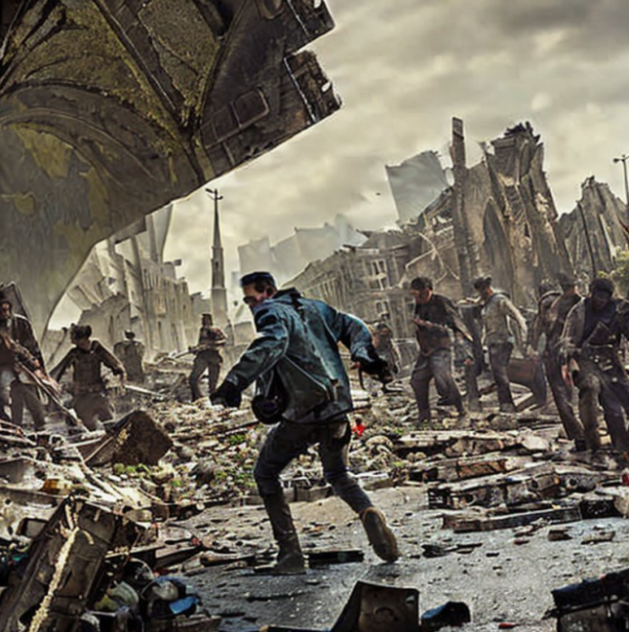

Day 01：

I'm writing this to keep my sanity intact and to tell the story of my journey through this crazy time to my kids(assuming there will be another generation), but now I have to be strong and survive.

I woke up in my bed to a world gone mad, and let me tell you, things were pretty f***ed up. My name is John Smith, and I'm just a programmer trying to make a living in Silicon Beach, LA. I live in my cozy little apartment on the ground floor, and life was pretty good. Or at least, it was until everything went downhill.

The sirens blared outside, their shrill wails cutting through the early morning silence. Lights flickered in the distance, and panic filled the air. People were running in every direction, their screams echoing through the streets. I could see smoke far away, and the smell of burning buildings made me feel sick. I had a sinking feeling that something terrible was happening, something beyond my wildest imagination.

As fear gripped my heart, I knew I had to gather my wits and survive as long as I could. I quickly grabbed the essentials, stuffing them into a backpack. Bottled water, canned food, a flashlight, and my trusty laptop. Hey, a geek's gotta have his priorities, right?

I stumbled out of my apartment, into the dimly lit hallway. That's when I saw them – the zombies. They were with red eyes and unpredictable movements. They smelled of rotten flesh that made me nearly puke. Oh boy, they weren't like the ones from the movies. These creatures were real, and they hungered for human flesh. My mind couldn't comprehend the horror unfolding before my eyes.

“What the...?!”

Without a second thought, I sprinted away from the approaching nightmare. Adrenaline surged through my veins, propelling me forward. I slammed the door shut behind me, my trembling hands fumbling to lock and bolt it. Collapsing to the floor, my legs gave way beneath me, and I sat there, panting, trying to catch my breath.

A thousand questions raced through my mind. How did this happen? Why were there zombies in my peaceful neighborhood? Was this some kind of rebellion against the government? But amidst the chaos and confusion, one thing was clear – I had to survive.

I took a deep breath, trying to steady my racing heart. The world outside was no longer the one I knew. It had become a place where the dead walked, and the living fought for their lives. As a kind of geeky guy, I never imagined I'd be living in a real-life horror movie, but here I was.

I stood up and glanced at the window. The sun was just beginning to rise, casting a pale glow over the devastation outside. Day one of the apocalypse, and it was up to me, John Smith, to navigate this nightmarish landscape and find a way to survive.

To be continued...

Date: November 3rd, 2047.

Day 02

Surprisingly enough, I managed to survive the first night. The zombies outside were relentless, scratching and pounding at the door, their hunger echoing through the halls. I needed a plan, a way to keep them out and stay alive. So, being the resourceful geek that I am, I turned to my trusted friend, Google. Or at least, I tried to.

I reached for my laptop, hoping to search for some survival tips, but to my frustration, the internet connection was down. Go figure, right? In this chaos, network errors were the least of my worries. Sighing sarcastically, I realized I'd have to rely on my own wits and the skills I acquired from summer camp.

I scavenged the apartment for anything I could use to fortify the door. Chairs, tables, and whatever furniture I could find were piled up against it, creating a makeshift wall. I even remembered a trick I learned during those camping days – jamming a folded magazine under the door to prevent it from easily swinging open.

Not stopping there, I wedged a chair under the doorknob, hoping to add an extra layer of security. I even bent a fork into the door latch, hoping it would buy me some time if the zombies managed to get through the barricade. Desperate times called for desperate measures, after all.

But I didn't stop with the door. I tightened a belt around the door hinge, just in case those undead creatures had a knack for picking locks. Duct tape and boards helped me reinforce the vulnerable spots and sealing any gaps that might let them in.

With my makeshift fortress in place, I turned my attention to the essentials – water, food and shelter. I scoured the kitchen, grabbing anything that could sustain me. Canned goods, snacks, and whatever I could find without attracting too much attention. I had some chewing gums and instant coffee on my working desk(help me stay awake when I was programming). I also found a box with candy in it on my shelf in the living room, but it looked like it was years old, so I dunno I could eat it or not. Well, I guess I'll have to make it last as long as possible by rationing.

Moving from room to room, I searched for a secure hiding spot. The bedroom was too obvious, and the living room seemed too exposed. Finally, I settled on a small storage closet tucked away in a corner of the apartment. It was cramped, but it provided some much-needed concealment.

Inside the closet, I took a moment to catch my breath and collect my thoughts. The sound of zombies clawing at the door grew louder, but for now, I was safe. I knew I couldn't stay hidden forever, though. Survival meant being smart and finding a way out of this nightmare.

As I huddled in the darkness, I made a mental note to stay calm and keep my wits about me.

To be continued...

Date: November 4th, 2047.

Day 05

The days blurred together, and my mental state teetered on the edge of insanity. I couldn't stay holed up in my apartment forever; I needed supplies to survive. With a deep breath and a pounding heart, I made the decision to venture outside into the unknown.

Preparation was key. I sat on the floor, surrounded by scattered papers, and created a shopping list and a map to the nearest store. The 7-11 seemed like the best bet, considering it was within walking distance. It was time to scavenge for food, water, and anything else that might come in handy.

|  |  |
| --- | --- |
| items | Check |
| Toilet paper | 🞎 |
| Food | 🞎 |
| Weapons | 🞎 |
| Petrol | 🞎 |
| Water | 🞎 |

But going outside unarmed was out of the question. I tore apart some old clothes and tied the fabric around my arms and hands, hoping it would provide some protection against the bites and scratches of the undead. I had no intention of becoming one of them anytime soon.

Guns were too risky, as the noise would surely attract more zombies. So, I had to settle for a cold weapon. I found a sturdy metal pipe that would serve as my improvised defense. It wasn't ideal, but it would have to do.

Leaving my Ford Fusion behind, its engine too loud to risk, I climbed through the window and into the eerie silence of the outside world. Sneaking through the desolate streets, my eyes darted around, scanning for any signs of danger. The sight that greeted me at the street made my blood run cold.

A horde of half a dozen zombies had surrounded a group of survivors, feasting on their flesh. My heart pounded in my chest, and I couldn't hold back a horrified scream. The zombies turned their attention toward me, their vacant eyes locking onto my presence. There was no time to waste; I had to escape.

Adrenaline surged through my veins as I fought back the panic, my instincts taking over. I ran as fast as my legs could carry me, dodging the grasping hands of the undead. I found a ladder leaning against a nearby building and scrambled up it, the fear pushing me higher.

Leaping from rooftop to rooftop, I sprinted with all my might. The zombies struggled to keep up, their sluggish movements no match for my desperate determination. As I distanced myself from the horrifying scene, relief washed over me. The escape was a success.

Using the map I had hastily drawn, I eventually found the 7-11. I cautiously entered the store and heard the sound of shuffling from behind the counter. As I slowly approached the counter, I saw a zombie with its back turned to myself, rummaging through some food cans. Its clothes are torn and covered in dirt and blood, and its skin is pale and lifeless.

The store had been raided, but I managed to salvage some much-needed supplies. It wasn't much, but it would keep me going for a while. As I creep around the store, I spot several useful supplies scattered about, including canned food, water bottles, and a medical kit. Just as I'm about to start gathering items, the zombie suddenly turns around and spots me. It lunges towards me with a guttural growl, causing me to quickly pull out my pistol and fire a shot directly into its forehead.

|  |  |
| --- | --- |
| items | Check |
| Toilet paper | 🗹 |
| Food | 🗹 |
| Weapons | 🗹 |
| Petrol | 🗷 |
| Water | 🗹 |

With my backpack loaded and a renewed sense of hope, I retraced my steps back home. Thankfully, I encountered no further zombie encounters along the way. As I collapsed onto my apartment floor, exhaustion took hold, and my mind began to wander.

Thoughts filled my head. Could it be that the zombies recognized humans and animals through smell? Maybe I could use that to my advantage, finding a way to mask my scent and move among them undetected. It was a glimmer of an idea, a flicker of hope in this grim new world.

Day 05 had been a harrowing journey, but I returned home alive, armed with supplies and newfound knowledge. The battle for survival was far from over, but I was ready to face whatever challenges lay ahead.

To be continued...

Date: November 8th, 2047.

Day 10:

Dear Diary,

I can feel myself getting worse, both in my body and in my mind. The constant fear and being all alone are really hard. I don't even know what day it is anymore—it feels like a never-ending bad dream. My body hurts, and I'm tired from always being on high alert.

The zombies have gotten smarter and keep trying harder to find me. They gather outside my apartment, scratching the walls and making those creepy moaning sounds. I know they'll break through my defenses soon. But I won't let them win. I won't let them turn me into one of them.

I've made up my mind. If I'm going to die, it won't be because of these terrible creatures. I won't give in to them. I won't let them take away who I am.

I have a plan—it's risky, but it's my only chance. I'll gather the little supplies I have left, find anything I can use as a weapon, and try to escape from this awful place. It's my last stand, and I'll fight with everything I've got until the end. I have to survive.

I don't know what's waiting for me outside my apartment, but I have to believe that it's something better. I have to believe that there's hope and a chance for things to get back to normal. I'll take that chance, for my own sanity and the hope of a future without this horrible nightmare.

Stay strong, John.

# **Chapter 2: Echoes of a Lost World**

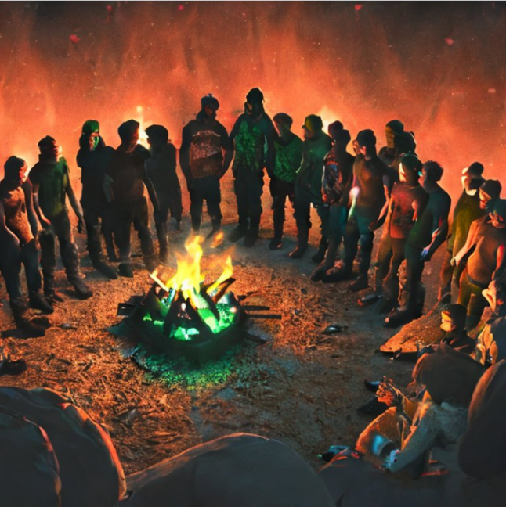

Day 12:

I was determined to escape from the confines of my old apartment, searching for a better and safer place to call home. Carefully, I packed the essentials I had managed to gather – food, water, toilet paper, clothes, and the weapons I had acquired. Along with my trusty Smith & Wesson Model 686 .357 Magnum, I also carried cold weapons for close combat.

Remembering the trick I had accidentally learned about masking my scent, I decided to try it out. I gathered pieces of rotten flesh from nearby zombies and stuck them onto my clothes, hoping that the smell would make me blend in with the undead. To my surprise, the trick worked, and I didn't attract any unwanted attention.

Silently, I made my way through the abandoned streets, using every ounce of caution. The fear of stumbling upon a horde of zombies was ever-present, but I stayed alert, determined to survive. Eventually, I reached the parking lot near my home, where my Ford Fusion, a lifeline to a potential escape, awaited.

Quickly, I piled the essentials into the trunk, making sure I had everything I needed. With a sigh of relief, I opened the gas cap and began to fill the tank. It was essential to have enough fuel to carry me away from this place of darkness and despair.

Once the tank was full, I climbed into the safety of my car, closing the doors tightly. Inside, I felt a sense of security, knowing that the metal shell would protect me from the ravenous creatures lurking outside. I double-checked everything, ensuring that there were no cracks or weaknesses that could allow the zombies to break in.

Finally, I turned the ignition, the engine roaring to life. It was time to hit the road, to venture into the unknown in search of survivors and a glimmer of hope. As I drove through the desolate streets, my eyes scanned the surroundings, hoping for any signs of life.

After what felt like an eternity, I spotted a two-story house with lights shining from its windows. It was a rare sight, a beacon of hope amidst the darkness. Parking my car nearby, I cautiously approached the entrance.

As I neared the locked door, a message caught my eye. Done with red spray paint, it read: "Password: 2047." It seemed like a door code, and it piqued my curiosity. With a sense of trepidation and anticipation, I pressed the password on the digital lock.

To my relief, the door unlocked and I opened the door, a group of survivors welcomed me warmly. I entered the apartment, the atmosphere was a mix of relief and curiosity. The group of survivors gathered around, eager to learn about the newcomer who had arrived on this fateful day. We sat together in a circle, finding solace in each other's presence. The conversation began, and introductions were made.

Mike, the rugged soldier, was the first to speak. His voice carried a sense of authority, yet his eyes reflected a genuine kindness. "Welcome, friend. I'm Mike. What's your name?" he asked, extending a calloused hand.

Nervously, I replied, "I'm John Smith, but you can just call me John. I'm a computer geek, not exactly cut out for the chaos we're facing."

Sarah, with a sparkle of curiosity in her eyes, chimed in next. "It's great to have you with us, John. I'm Sarah. I have a knack for scavenging and finding hidden resources. We'll need all the supplies we can get."

Jacob, the handy mechanic, nodded in agreement. "Indeed, John. I'm Jacob. If there's a vehicle that needs fixing or improvising, I'm your guy. We'll need reliable transportation in this new world."

Dr. Emily Carter, the brilliant scientist, smiled warmly. "Welcome, John. I'm Dr. Emily Carter. My expertise lies in the field of biology and research. Together, we may find a way to understand and combat the zombie menace."

Feeling a sense of acceptance among these resilient individuals, I opened up further. "Thank you all for the warm welcome. It's reassuring to know that I'm not alone in this nightmare. I may not have any special skills, but I'm willing to learn and contribute in any way I can."

Mike nodded, his gaze unwavering. "John, we all have our strengths and weaknesses. In this world, survival depends on the unity of our abilities and the will to keep fighting. Together, we can face the challenges that lie ahead."

The conversation continued, flowing between tales of survival, shared knowledge, and plans for the future. Each member of our group had their own unique stories, their own scars from this apocalyptic world. But in this circle, we found strength and a glimmer of hope.

As night fell outside, casting shadows upon our refuge, a sense of camaraderie filled the air. We had become more than just survivors. We had become a family bound by our shared struggle and determination.

In the face of uncertainty, we vowed to support and protect each other. Our words carried a deep conviction as we made a silent promise to stand together, facing whatever challenges this apocalyptic world threw our way.

To be continued...

Date: November 15th, 2047.